Move page - mouse wheel down

Move tool
Allow movement only in one direction - Ctrl

Color swatches
change stroke color – shift + click

Shapes
Keep ratio – ctrl
Draw from center – shift

Elipse
Slice of pie – Circular handle outside
Arc – Circular handle inside

Star
Inner radius, skew unless ctrl – Inner diamond handle
Outer radius, rotation unless ctrl – Outer diamond handle
Rounding – Handle + shift
Randomization – Handle + alt

Organization of layers
Layers and objects [dockable dialog] – Shift + ctrl + L
Group – ctrl + g
ungroup – ctrl + shift + g
Enter group to place new objects inside group – Double click onto group or enter group (L&O dd., right click dialog)
Exit group – Double click outside
[In the top bar] Adjusting the z-index
[L&O dd.] Opacity, visibility and locking

Scale
Keep ratio – ctrl
Scale from both sides – shift
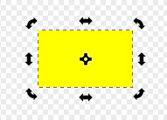Rotation center

Rotation & skew
15° increment – ctrl
Rotate or skew around opposite corner – shift

Copies & clones
Copy → Changing the original won’t change the copy
Clone → Changing the original will change the clones
Unlink clone: [TB] Edit – Clones – Unlink clone

Align and distribute
Open dockable dialog [DD] – Shift + ctrl + A

Paths
Caligraphy tool – caligraphic lines
Settings e.g: caps = rounding of line ends
Pencil tool
Freehand lines
Path tool
Shift (when creating point): Moving one handle independently
Finish: click other end to connect ends or (right click or enter) to leave open

Node tool
Corner node = no curvature
Cusp node = curvature (handles entirely move independently)
Smooth node = curvature (handles remain in the same line, can have different length)
Symmetrical node = curvature (handles have same length are in the same line)
Auto smooth = curvature (keeps curve smooth)
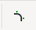
Square = Smooth or curved node
Cusp node = diamond
Add node – [TB], double clicking path
Delete node – Delete key
Break apart path – [TB]
Join two nodes together or connect unconnected nodes – [TB]
Rounding at a node – [TB]
It is advisable to “flatten” paths with path effects into normal paths: possible with object to path (Shift + ctrl + c)

Boolean path operations
Exclusion = symmetrical difference
Division = difference but leaves them as different objects
Cut path = division but only stroke
Combine = moves all objects into a single objects
Break apart = opposite of combine; enclosed empty areas will be filled in
Split path = opposite of combine, enclosed empty areas won’t be filled in
Fracture = cut overlapping paths into segments
Flatten = removes parts from objects covered by other objects
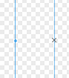Unlocked guideline (left), locked guideline (right)

Guidelines
Toggle rulers – Ctrl + R
Diagonal guideline – Corner of the rulers
Rotate rulers – shift + pull with left button pressed
Move guideline’s origin point without moving the guideline – ctrl
Guideline dialog – double click on guideline
[TB]: Edit – Lock all guides
Delete guideline – Delete while hover
[TB]: Edit – Delete all guides
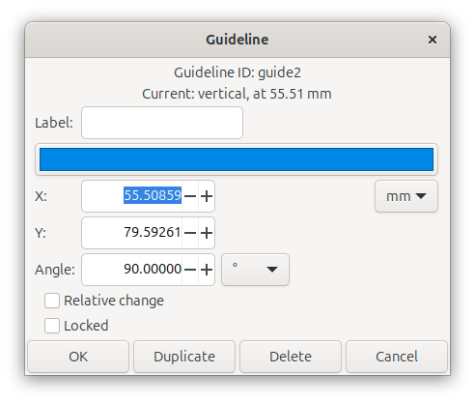Guideline dialog

Grids
[TB]: Page – Grid
Settings [TB]: File – Document properties – Grids
Toggle visibility – [TB]: View – Page grid

Fill & stroke
Custom dashes: dash gap dash gap …

Eyedropper
Set dropped color as stroke color – Shift
Average – Click and drag

Blur
Can change with the node tool in directions separately

Gradient tool
Radial gradient change the length of both lines – shift + ctrl
Radial gradient move focus – shfit

Patterns
If you want to be able to change the color of the pattern later it should be set to Unset
Get objects from pattern [TB] Object – Pattern – Pattern to objects
Create pattern from objects [TB] Object – Pattern – Objects to pattern

Texts
Text and font DD has some special text
[TB] Text – Text to glyphs can separate characters of text even if they touch (e.g. in case of a cursive font)(this is useful, because this wouldn’t be possible with break apart or split path)
Object to path will group multi-line texts by lines
If you want to remove the path the text was put onto you have to covert the text to an object first
[TB] Text – Put on path aligns a text onto the curvature of a path
Can undo with [TB] Text – Remove from path
Can also align text onto shapes
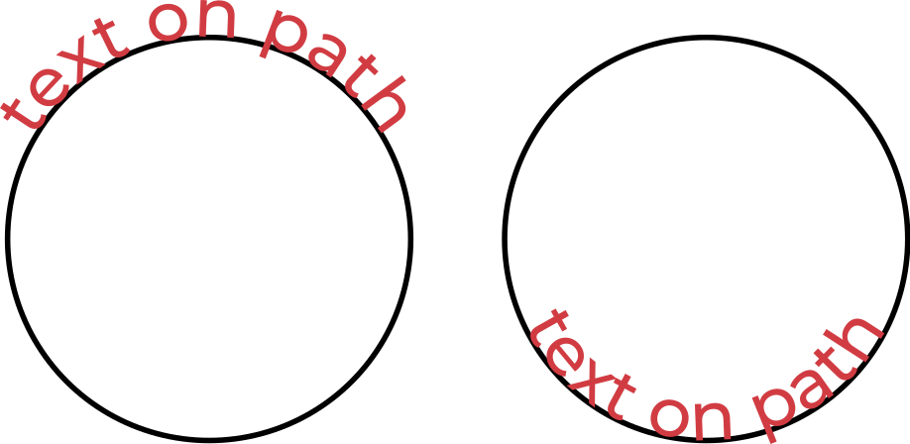If you want to center the text placed onto the curvature of an ellipse remember to set the text to center align before putting the text onto the curve. Text can also be placed onto the inside curvature of a ellipse by mirroring the text placed onto the ellipse.

